**Structure of the US banking system**

**Federal Reserve System (The Fed)**

The central bank of the United States, responsible for conducting national monetary policy, supervising and regulating banks, maintaining financial stability, and providing financial services.

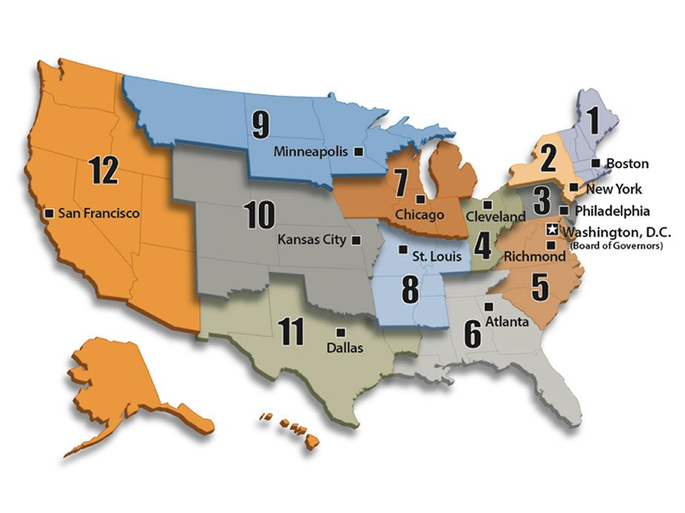

A network of 12 Federal Reserve Banks and 24 branches make up the Federal Reserve System under the general oversight of the Board of Governors.

**The Federal Reserve:**

* **Conducts the nation's**[**monetary policy**](https://www.federalreserveeducation.org/about-the-fed/archive-structure-and-functions/archive-monetary-policy/) to promote maximum employment, stable prices, and moderate long-term interest rates in the U.S. economy.
* **Promotes the stability of the financial system** and seeks to minimize and contain systemic risks through active monitoring and engagement in the U.S. and abroad.
* **Regulates the** [**safety and soundness of individual financial institutions**](https://www.federalreserveeducation.org/about-the-fed/archive-structure-and-functions/archive-banking-supervision/) and monitors their impact on the financial system as a whole.
* **Supports** [**payment and settlement system**](https://www.federalreserveeducation.org/about-the-fed/archive-structure-and-functions/archive-financial-services/)**safety and efficiency** through services to the banking industry and the U.S. government that facilitate U.S.-dollar transactions and payments.
* **Fosters** [**consumer protection**](https://www.federalreserveeducation.org/about-the-fed/consumer-protection/)**and community** **development** through consumer-focused supervision and examination, research and analysis of emerging consumer issues and trends, community economic development activities, and the administration of consumer laws and regulations.

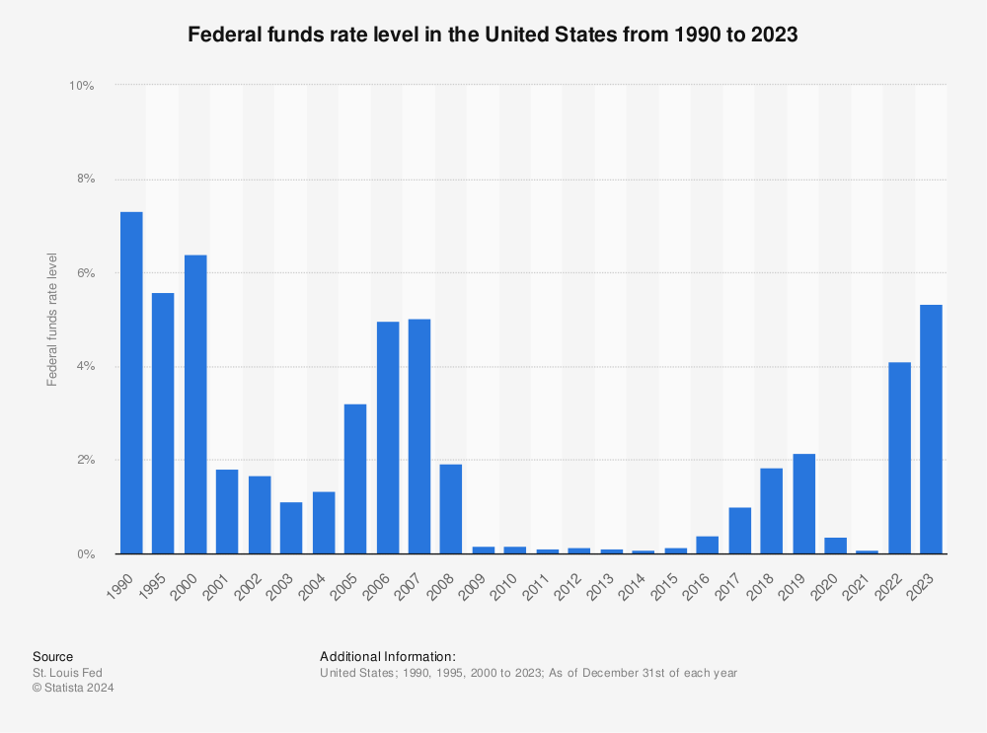

**Commercial Banks**

Banks that provide a wide range of services such as accepting deposits, providing business and personal loans, and offering basic investment products. Includes large national banks, regional banks, and community banks.

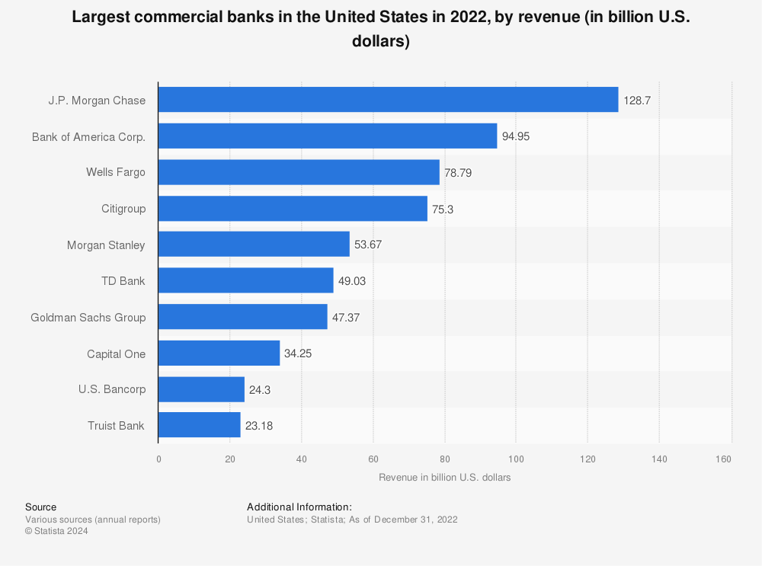

**Savings and Loan Associations (Thrifts)**

Financial institutions that primarily focus on accepting savings deposits and making mortgage loans. They are also known as thrifts and have a primary mission of promoting homeownership.

**Credit Unions**

Member-owned financial cooperatives that provide a variety of financial services similar to those of commercial banks. They operate on a non-profit basis, returning earnings to members in the form of lower fees and higher savings rates.

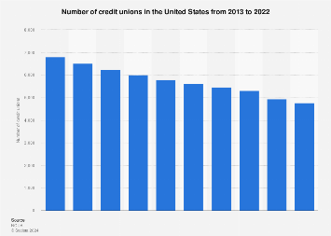

**Investment Banks**

Banks that specialize in large and complex financial transactions, such as underwriting, acting as intermediaries between securities issuers and investors, facilitating mergers and acquisitions, and providing advisory services.

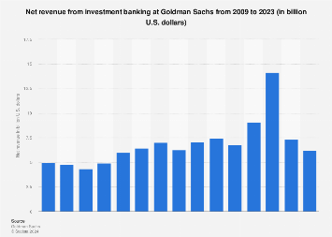

**Bank Holding Companies**

Corporations that own and control one or more banks. They can engage in a broader range of financial activities compared to traditional banks, including owning non-bank subsidiaries.

**Non-bank Financial Institutions (NBFIs)**

Financial entities that provide various financial services but do not have a full banking license. These include insurance companies, hedge funds, mutual funds, and finance companies.

**Federal Deposit Insurance Corporation (FDIC)**

An independent agency that insures deposits at banks and thrifts, supervises financial institutions for safety and soundness, manages receiverships, and promotes consumer confidence.

**Office of the Comptroller of the Currency (OCC)**

A bureau of the U.S. Department of the Treasury that charters, regulates, and supervises all national banks and federal savings associations. Ensures that they operate safely and soundly and comply with applicable laws.

**National Credit Union Administration (NCUA)**

An independent federal agency that charters and supervises federal credit unions and insures savings in federal and most state-chartered credit unions. Promotes stability and confidence in the credit union system.

**State Banking Regulators**

State-level agencies that charter, regulate, and supervise state-chartered banks and other financial institutions. They work in coordination with federal regulators to ensure the safety and soundness of state-chartered entities.

**Consumer Financial Protection Bureau (CFPB)**

An independent agency that enforces federal consumer financial laws, supervises financial institutions for compliance, and works to protect consumers from unfair, deceptive, or abusive practices in the financial sector.

**How US banking perform**

The primary function of banks is to lend account holders’ money to other people, who will use that money to buy homes, businesses, or send their children to college.

When you deposit your money at a bank, that money goes into a large pool of money, and the amount of money that you deposited is credited to your account.

Money is subtracted from your account when you write checks or make withdrawals. Money is also added to your account as you accrue interest. Banks create money in the economy by making loans.

**How to generate revenue**

Diversified banks make money in a variety of different ways; however, at the core, banks are considered [lenders](https://corporatefinanceinstitute.com/resources/commercial-lending/lender/). Banks generally make money by borrowing money from depositors and compensating them with a certain interest rate. The banks will lend the money out to borrowers, charging the borrowers a higher interest rate and profiting off the interest rate spread.

Additionally, banks usually diversify their business mixes and generate money through alternative financial services, including [investment banking](https://corporatefinanceinstitute.com/resources/valuation/investment-banking-book-pdf/) and wealth management. However, broadly speaking, the money-generating business of banks can be broken down into the following:

1. Interest income
2. Capital markets income
3. Fee-based income

### **Interest Income**

Interest income is the primary way that most commercial banks make money. As mentioned earlier, it is completed by taking money from depositors who do not need their money now. In return for depositing their money, depositors are compensated with a certain interest rate and security for their funds.

### **Capital Markets-Related Income**

Banks often provide capital markets services for corporations and investors. The [capital markets](https://corporatefinanceinstitute.com/resources/career-map/sell-side/capital-markets/capital-markets/) are essentially a marketplace that matches businesses that need capital to fund growth or projects with investors with the capital and require a return on their capital.

### **Fee-Based Income**

Banks also charge non-interest fees for their services. For example, if a depositor opens a bank account, the bank may charge monthly account fees for keeping the account open. Banks also charge fees for various other services and products that they provide. Some examples are:

* Credit card fees
* [Checking accounts](https://corporatefinanceinstitute.com/resources/wealth-management/checking-account/)
* Savings accounts
* Mutual fund revenue

**What is different process US banking of Indian banking**

Compared to American banks Indian banks are more stable and are in a stronger position as the ratio of lending and deposit is vast. Whereas American banks, till the recession they give the loan even to people with zero income upon some guidelines. American banks don’t work on Saturday's whereas Indian banks will work. In India we can't transfer money to overseas through online, we need to do the paperwork and the execution takes 2 to 4 days but in USA it takes only a few minutes. In India, every bank has a handful of branches through which the work can be done easily but in USA, the banks have only a few branches, some of them are regional operations.

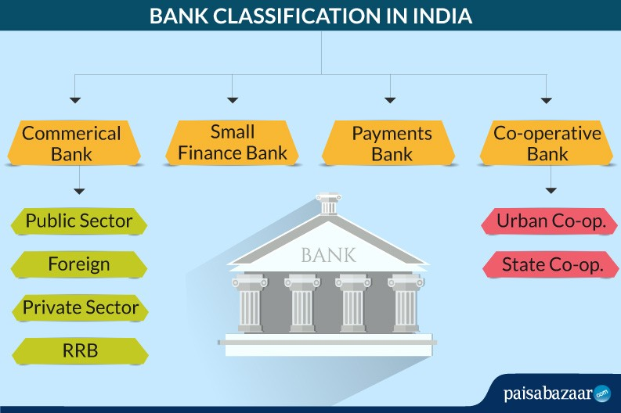

In India, there is only one statutory central bank that is Reserved Bank of India (RBI) whereas USA has 12 Federal Reserve Banks whose responsibilities are described to it's areas depending on geographical boundaries but the Federal Reserve Bank has more powers compared to the RBI governor. The federal bank's work independently and has more freedom whereas the RBI is under the control of the central government. In India the banking system is in such a way that the banks borrow money from RBI very rarely but in USA the banks can frequently borrow money from federal bank and the rate of interest changes very rarely in RBI whereas in the federal banks it changes frequently.

American banks work on new technology and keep on updating, whereas India is still adapting to the new technology. In America banks personal and business banking is done easily through apps on the smartphone or tabs. Mobile banking even helps us to fight the frauds by showing us any sort of suspicious activity. It is secure and has benefits too. It has contactless banking which helps us to touch less surfaces which are secured with PIN. They are secured very well from being fraudulently used. Indian banks give various offers to customers to serve their needs. They can open a bank account with a minimum balance. They offer loans to buy cars, bikes and houses and help the students to take the top institutes by giving educational loans. They provide allied deposit schemes, ancillary schemes and various schemes which help the customer in saving the amount and benefiting out of that. They even provide retirement plans, smart future for a safe living. Allied scheme helps the customer in doubling the investment in a few years. Both Indian and American banks work for the people and help them with their services.